**RIPHAH INTERNATIONAL**

**UNIVERSITY, ISLAMABAD**



**Lab#2**

**Bachelors of Computer Science – 5th Semester**

**Subject: Operating System**

Submitted to: Ms. Kausar Nasreen Khattak

Submitted by: Ayiza Waqar

Date of Submission: 03-Sep-2024

**Task#1:**

To begin, you need to set up a structured directory layout in your home directory. Start by creating two directories named **OS_Course** and **OS_Lab**. These directories will serve as the main folders for organizing your OS Lab tasks. After creating these directories, switch to the **OS_Lab** directory. Within OS_Lab, create three more directories named **LAB_Class_Task, LAB_Activities, and Lab_Practice**. Each of these directories will help you categorize different aspects of your lab work. Once you have created these directories, go into the **Lab_Practice** directory and create a file named example.cpp. This file should be empty and will be used for practice later. Finally, move back to your home directory. Make sure to take screenshots of each step, including the creation of directories, the file creation, and your navigation commands to document your process.

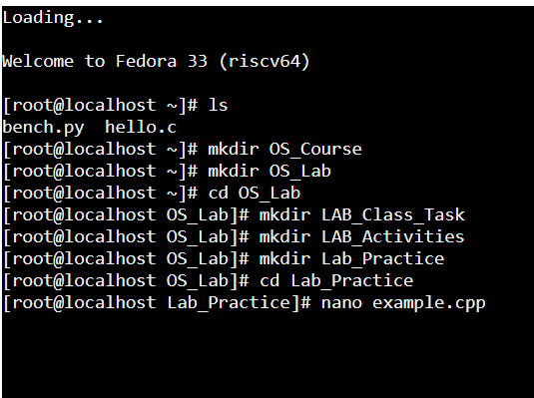

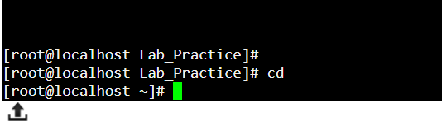

**Creating Main Directories:**

We will start by creating two main directories: OS_Course and OS_Lab. These directories act as the top-level folders for storing all your course materials and lab work.

**Subdirectories for Organization**

Inside the OS_Lab directory, we created three subdirectories: LAB_Class_Task, LAB_Activities, and Lab_Practice. Each of these folders will help categorize different types of lab work:

LAB_Class_Task: Likely to hold tasks assigned during class.

LAB_Activities: For general lab activities or exercises.

Lab_Practice: A space for practicing coding or assignments.

**Task#2:**

Finally, you need to understand the concepts of absolute and relative paths. Explain the difference between these two types of paths and provide an example of each. This will help you navigate directories more effectively. If you are currently in the Lab_Practice directory, describe the relative path to access the **LAB_Activities** directory. This will test your understanding of how to move between directories using relative paths.

**Absolute Pathname:**

The pathname, which identifies a file or a directory irrespective of the current state of the user. The user's "current directory" is part of the user's state. The absolute pathname always starts from the root directory.

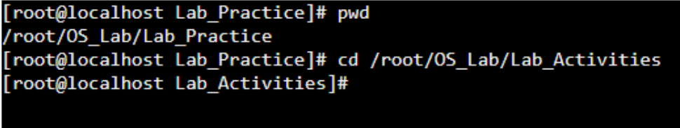

**Relative pathname:**

The pathname, which identifies a file or a directory in a way that depends on the state of the user i.e. users current directory. Relative pathname identifies files with respect to user current directory.

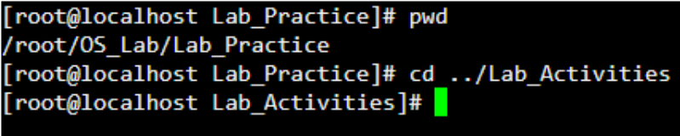

**Task#3:**

Imagine you’re working on your computer when you suddenly need to turn it off quickly. You press and hold the power button until the computer shuts down completely. After an hour, you turn the computer back on, and it quickly shows the login screen or desktop.

Why does your computer start up smoothly and quickly after being turned off? Describe the process that happens between powering off the computer and seeing the login or desktop screen. What steps does the computer go through to get everything ready in a short amount of time?

**Solution:**

When you hold down the power button to force a shutdown, the system automatically saves your work, terminates active processes, and powers off. Upon restarting, the computer runs a Power-On Self Test (POST) to verify the functionality of key components such as RAM and storage devices. It then loads the Basic Input/Output System (BIOS) or Unified Extensible Firmware Interface (UEFI) to initialize the hardware and ensure everything is in order before proceeding.

Next, the operating system is loaded from the storage device (like an SSD or HDD) into the system’s memory (RAM). During this stage, essential drivers and background services are initialized to prepare the system for use. Since the computer was properly shut down before, the boot process happens efficiently, bringing you quickly to the login screen or desktop, ready for action.